GEON points2grid Utility Out-of-Core Implementation
Design Sketch

Author: Han S Kim (hskim@cs.ucsd.edu)

1. GENERAL IDEA OF OUTOFCORE
The out-of-core version uses a secondary storage to store intermediate results during DEM computations.

Think of a big two-dimensional array and we want to divide the array into several pieces. The decomposition technique that I used is row-wise decomposition i.e. the array is decomposed into several stripes that have long width and short height.

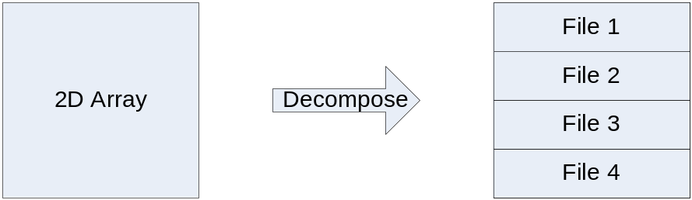

Interpolation::MEM_LIMIT stands for the maximum memory size that can be used to allocate one decomposition block. That is the size of each stripe cannot exceed MEM_LIMIT. Therefore, according to the size of the original 2D array, we have to decide how many decomposition units we need. For example, if MEM_LIMIT=10 kbytes and if we have a 2D array of size 20 kbytes, we need 2 blocks whereas we need 10 blocks if we allocated 100KB for the 2D array.

2. Block Processing
The program uploads in memory only one stripe at a time. Meanwhile, the program also reads point cloud data from the input file. Let suppose the program have read a point P_1=(x, y, z). P_1 may or may not be in range of the stripe we have uploaded in memory. If P_1 is not inside of the stripe, we enqueue P_1 into a proper queue (we will discuss later again). If P_1 is inside of the stripe, we update the DEM points around P_1.

Example.
Grid[100][100] is decomposed into 5 files
Stripe 1: Grid[0-19][100]
Stripe 2: Grid[20-39][100]
Stripe 3: Grid[40-59][100]
Stripe 4: Grid[60-79][100]
Stripe 5: Grid[80-99][100]

Let assume we have used the resolution of 1ft and stripe 1 is uploaded in memory.
Now let suppose we have read P_1 = (10.9, 50.3, 70.0).
Then P_1 belongs to Stripe 1 because 10.9 >=0 && <= 19. Therefore, P_1 can update stripe 1.
Next, let suppose P_2 = (60.3, 50, 70) has been read. Because P_2 is out of range with stripe 1 and P_2 belongs to stripe 4, P_2 is enqueued into Q4, which is matched to stripe 4.

3. Queueing
As you can see in the example above, P_2 is enqueued into Q4. In general, each stripe has its own queue and each point is stored one of them. If the length of a queue exceeds the limit, the stripe corresponding to the queue is uploaded into memory and the stripe that was in memory is swapped out into secondary storage. This queueing mechanism seems to have many possibilities to be enhanced. I just choose this mechanism because it is the simplest and easiest to implement. We can analyze the behavior of swapping and queueing with the queueing theory or with a simple theoretical modeling.

4. Overlap
The tricky part in the decomposition is the overlap. Consider P_2 in the example above. P_2 updates the grid points around P_2. The problem is that the points in stripe 3 may need to be updated too. Therefore, each stripe contains additional array elements. For example, the area of stripe 3 is [38-61][100]. The size of the overlap changes according to the relationship between search radius and grid resolution.

overlapSize = (int)ceil(sqrt(radius_sqr)/GRID_DIST_Y);

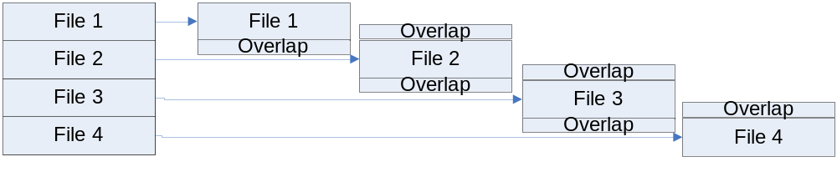

5. How many files?

>> numFiles = (int)ceil((double)GRID_SIZE_X * GRID_SIZE_Y / (Interpolation::MEM_LIMIT - (2 * overlapSize + 1) * GRID_SIZE_X));

GRID_SIZE_X * GRID_SIZE_Y denotes the size of array we are using.
Interpolation::MEM_LIMIT is the maximum size of memory that can hold a stripe.

The equation above is derived from the following:

numFiles * MEM_LIMIT = (GRID_SIZE_X*GRID_SIZE_Y + (2 * overlapSize + 1) * GRID_SIZE_X * numFiles);

The second term in RHS is the memory size of overlap. The overlap size increases as the number of files we are using increases. Also, each stripe has two overlap areas, top and bottom.

6. Memory Mapped File
The memory mapped file mechanism is used in this implementation. The memory mapped file is an interface between files and memory. If you want to read and write a file, the easiest way is, 1) open the file, 2) read a line or a block into memory, 3) read and write, and 4) write back the result. Another way is to use memory mapped file, which maps a file into memory region so that reading and writing memory have the same effect as reading and writing the file. Once you succeeded in mapping the file, it is really convenient to modify the file. The performance has been known comparable to primitive standard I/O library function calls.

7. Data Structures
- GridMap[]: This array contains a pointer to GridFile and boundary information. The boundary information denotes the offset in the original 2D array.
- GridFile: This class abstracts all the detail about memory mapped operations. Map() and unmap() operations are the main operations.

8. Finishing step

After finishing reading a point cloud file, the final step is to merging stripes into one. The main stripes except overlapped parts stay the same. However, the areas that overlap between stripes need to be updated. For example, the information in the upper side overlap region of file 2 should be reflected in file 1. The lower side region should update file 3.

